Matthew McNeive

ENVS 101 - The Scientific Basis of Environmental Issues

Dr. Gregory Palmer

Final Semester Project

There are a great number of issues that the global environment has been facing for a long time. The biggest and most prominent issue is the rapidly changing climate. While this issue is debated greatly, all sources of science indicate that human intervention has been the direct cause of climate change. While there are many factors that cause this, undoubtedly one of the biggest is the greenhouse gas emissions caused by the usage of fossil fuels. The purpose of this project is to analyze and visualize data about fossil fuel usage and see if there is a correlation between the increase of greenhouse gas emissions and an increase in the average global temperature. The prediction is that we will be able to see a direct correlation between these two factors, thus indicating that human actions have led to climate change.

The process for this research began with finding suitable data to analyze and visualize. The data that was selected for this was not only meaningful but also structured in a way that could be easily read and worked with. The hypothesis that I hoped to prove with the data is that carbon emissions, primarily the burning of fossil fuels, has directly led to an increase in the average temperature of the planet. There are 3 datasets that were used. The first one measures temperature anomalies every year from 1880 to 2016. The temperature anomalies are recorded in degrees Celsius where the positive values represent hotter than average temperatures. The further that the value is from zero means that the anomaly is greater than ones closer to zero. The second data set records global CO2 emissions from fossil fuels since 1751. It breaks the data into the various fossil fuels (gas fuel, liquid fuel, etc.) and records the total amount used globally per year in terms of million metric tons of carbon that were produced. The final data set that was used is a measurement of the total CO2 emissions per country per year. This data also has values for the continents as a whole so that is the data that was selected.

I used a number of technologies for this project. The main technology that was used is the language python. Python was the best choice because it is very lightweight and has a number of libraries that can be used that specialize in data and data visualization. The 2 libraries that I used are Pandas and Matplotlib. I had to spend some time learning these libraries, as I have never used them prior to this project. Pandas was used for the way that it structures data. It’s focal point is a structure called DataFrames which stores data in a table-like format. Matplotlib is a library used for data visualization. The general process for this project is as follows. The data was downloaded in the form of a CSV and stored in a Pandas DataFrame. If necessary, the data was altered or reorganized using Python scripts. Finally, the data in the DataFrame was plotted on a graph using Matplotlib. In the end, the syntax for the scripts is rather simple. The challenge came in learning these libraries and determining the best way to organize and display the data.

My hypothesis for this research was that the drastic increase in the production of greenhouse gases from the usage of fossil fuels can be directly tied to an increase in positive temperature anomalies. Positive temperature anomalies indicate that the temperature of the planet is rising at a rate greater than expected. Using the data that has been visualized, the expectation is that when the usage of these fossil fuels begins to increase, we will also be able to see an increase in the number of positive temperature anomalies. While fossil fuels are not the only factor contributing to the changing climate, the EPA estimates that industry and energy production, which both heavily rely on fossil fuels, contribute 46% to the total greenhouse gas emissions worldwide (Global Greenhouse Gas Emissions Data). Given this estimate, we should be able to see a direct correlation between the rise in fossil fuel use and the increase in positive temperature anomalies.

Firstly, we are able to see a breakdown of the amount of carbon emissions, per continent, since 1751, just prior to the Industrial Revolution. This is the first time in human history when we see a widespread usage of fossil fuels and thus is a good starting point for the data. This graph represents what we would expect from data regarding greenhouse gas emissions. The data lines first begin to increase around the mid-to-late 1800s which is when coal was first used for energy production. However, the biggest increase we can see begins around the start of the 1950s. This correlates with the fact that this time saw the biggest increase in industry and production and the biggest demand for energy. In addition to this, we can also see that Africa and South America have not contributed to CO2 emissions as much and Asia is by far the biggest contributor. They key takeaway from this graph is that while we see a constant increase in greenhouse emissions, we see the most drastic spike starting around 1950.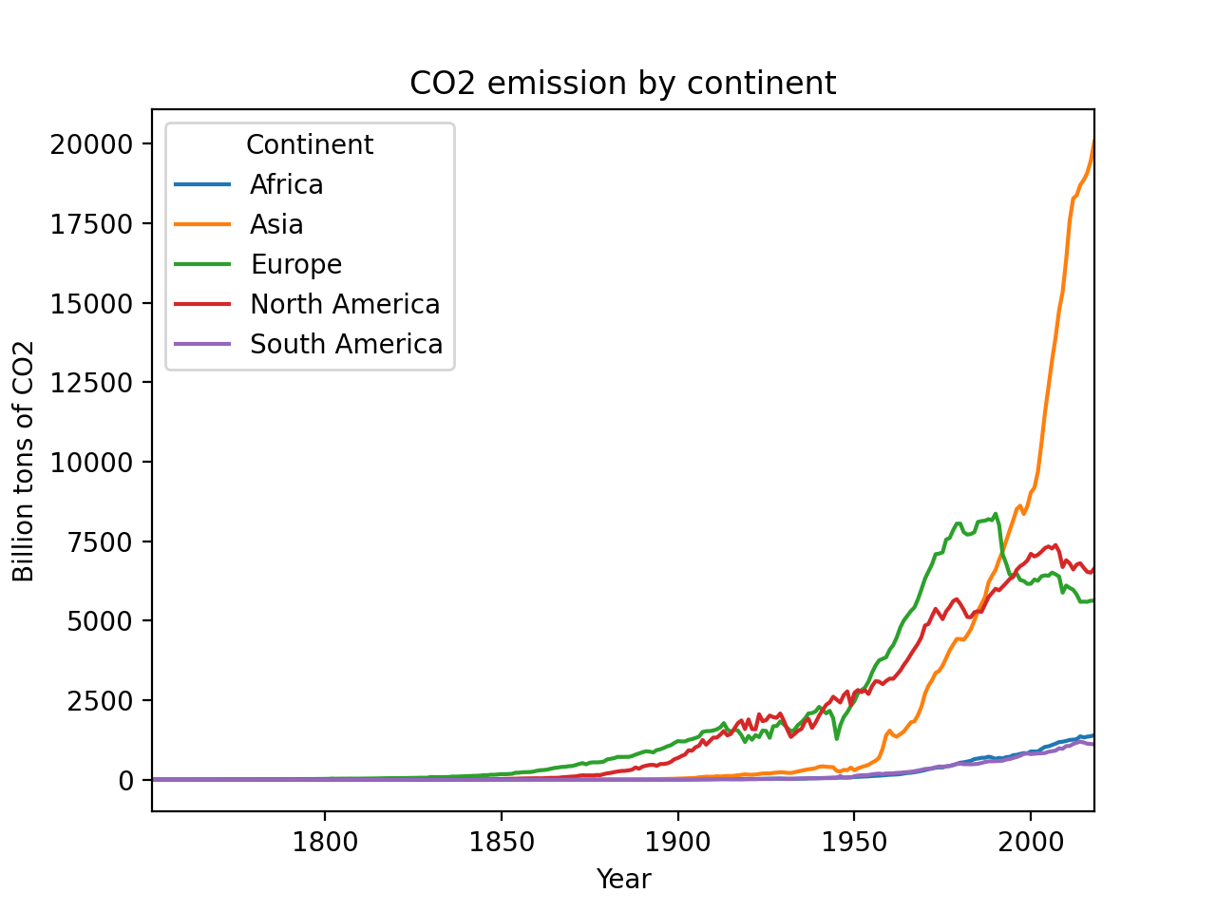

The second data source gives a different perspective. This data source looks at the global usage of fossil fuels and breaks it down by type. This data provides a lot of interesting information about how much we depend on the various forms of fossil fuels. However, the most important part of this graph for this purpose is the trend. This data and the one from the previous section come from different sources, however show very similar data. In this data, just like the previous one, we can see a steady increase up until the mid 1900s when we see a massive spike in the usage of fossil fuels. Since both of these sets of data show similar trends, we can determine that there was a massive increase in greenhouse gas emissions worldwide starting in the 1950s. Given this, we should expect that the global temperature data will reflect this and we should see an increase beginning at that time.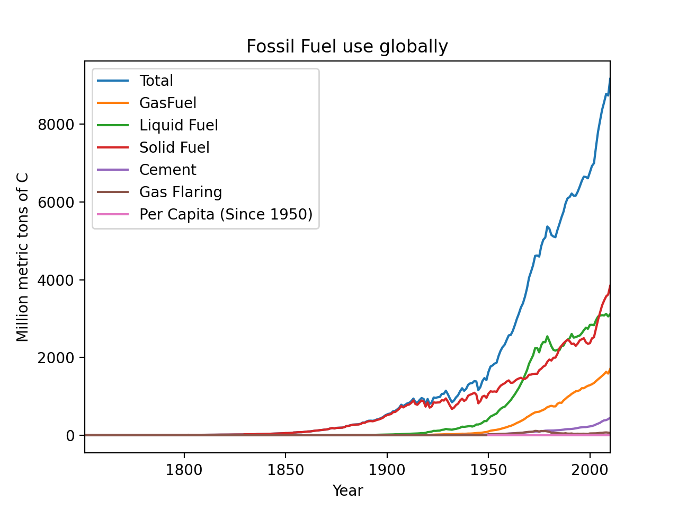

Data pertaining to the global temperature comes from two sources. The first (shown below in blue) comes from the Global component of Climate at a Glance, who collected their data from both the Global Historical Climatology Network and International Comprehensive Ocean-Atmosphere Data Sets. The second source (shown below in red) comes from GISTEMP who collected their data from a combination of Land-Surface Air and Sea-Surface Water Temperature Anomalies. This data, even though from two different sources, shows nearly identical information. We can see that the number of positive temperature anomalies has been increasing considerably over the past 140 years. However, we now have to determine if this data concerning temperature anomalies can be correlated to the data of fossil fuel usage and greenhouse gas emissions. 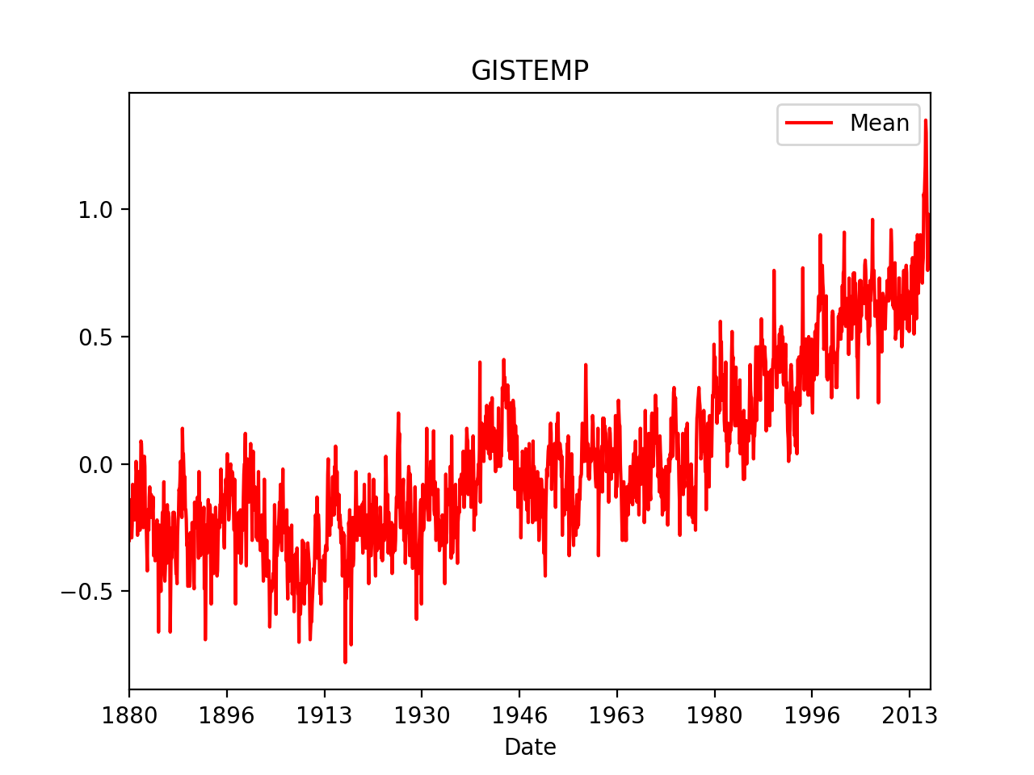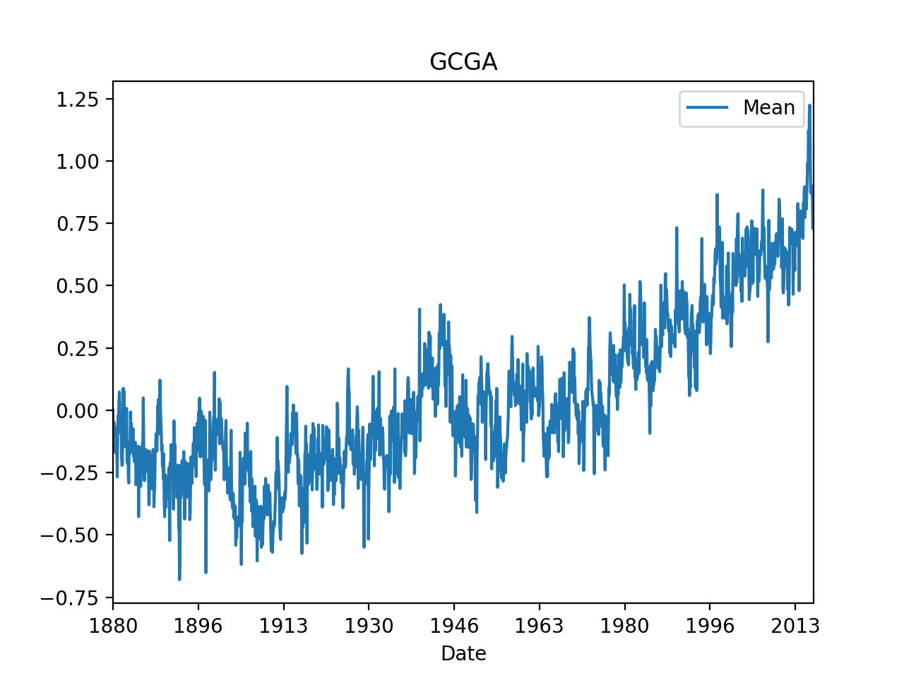

The data from both GCGA and GISTEMP show similar trends, and we can see two times when the temperature is increasing. The first starts around the early 1900s. Looking back at the fossil fuel graphs, we can also see that the amount of emissions being produced can be seen to increase during this time. However, the temperature anomalies seem to flatten out close to 0 from 1945 - 1960 and we even start to see more negative temperature anomalies. In the period directly leading up to this, fossil fuel usage also did not increase, but rather remained stagnant. However, we can see the greatest increase in temperature anomalies starting just after 1960 and it has not stopped rising since. This period of increased temperature begins just after the boom in fossil fuel usage. Overall, the trends in global temperature change seem to reflect the greenhouse gas emissions caused by fossil fuels.

When considering all of this data, it is hard to deny that fossil fuel usage has led to an increase in the temperature of the planet. This data proves that our actions and choices concerning industry and energy production have consequences. The consequence is a rising temperature of the planet and if nothing is done soon then the damage will become irreversible. While many factors can be attributed to rising temperatures, fossil fuels are by far the biggest contributor. This project was completed in a way to visualize the problem and show that there is a direct correlation between the usage of fossil fuels and the changing climate.

Citations

“Global Greenhouse Gas Emissions Data.” *EPA*, Environmental Protection Agency, 10 Sept. 2020, www.epa.gov/ghgemissions/global-greenhouse-gas-emissions-data.

*GISTEMP: NASA Goddard Institute for Space Studies (GISS) Surface Temperature Analysis, Global Land-Ocean Temperature Index.*

*NOAA National Climatic Data Center (NCDC), global component of Climate at a Glance (GCAG).*

*Boden, T.A., G. Marland, and R.J. Andres. 2013. Global, Regional, and National Fossil-Fuel CO2 Emissions. Carbon Dioxide Information Analysis Center, Oak Ridge National Laboratory, U.S. Department of Energy, Oak Ridge, Tenn., U.S.A. doi 10.3334/CDIAC/00001_V2013*

*Ritchie, Hannah, and Max Roser. "CO₂ and greenhouse gas emissions." Our world in data (2017).*